FORMATION RESOURCES
In a culture that is often hostile to religion or public reference to God, the Knights of Columbus provides inspiring resources to help Catholic men grow in their faith and become better husbands and fathers.
Join Us – go to…
www.Knights.net

PRAYER RESOURCES
Deepen your prayer life or start a new prayer routine. Here you will find booklets on praying the rosary, how to make an examination of conscience, devotional prayer cards, and guidance on other Catholic practices. The goal for Knights is to grow in holiness through closeness to Jesus Christ and his Church.
Join Us – go to…
www.Knights.net

the duty to defend
Knights are called to defend the vulnerable, our religious rights, and our communities. It is our duty as Catholic men to stand up for the values that support the common good and form our culture. With the Order’s experience and the commitment of 1.9 million members, we seek to make a positive difference.
Join Us – go to…
www.Knights.net

defending life, liberty, and truth
Learn more about how the Knights of Columbus amplifies your voice for the good of the Church, your country and the culture by defending the timeless values based on faith, family and freedom. Together as Knights, we can help preserve what is good and true in our society.
Join Us – go to…
www.Knights.net

issues
As the world's largest Catholic fraternal organization, the Knights of Columbus supports issues related to faith and the common good, especially in the areas of culture of life, marriage and family, religious freedom, and being the strong right arm of the Church.
Join Us – go to…
www.Knights.net

HOW WE SERVE
Knights of Columbus are known for their personal, hands-on service to those most in need. While the annual amount of dollars donated is impressive, Knights also pride themselves on the millions of hours logged in labor for the poor and the marginalized. In 2016, Knights of Columbus gave more than $177.5 million to charitable causes, and put in more than 75 million volunteer hours on worthy projects.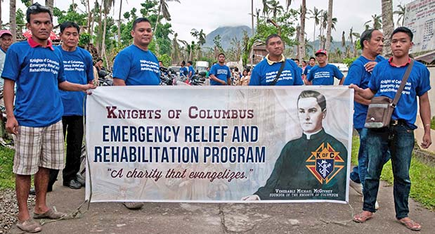.
Join Us – go to…
www.Knights.net

